# CSC 150: Computer Science I

# Assignment 1

Overview of C

**Learning Objectives**

* To become familiar with the general form of a C program and the basic elements in a program
* To appreciate the importance of writing comments in a program
* To understand the use of data types and the differences between the data types int, double, and char
* To know how to declare variables
* To understand how to write assignment statements to change the values of variables
* To learn how C evaluates arithmetic expressions and how to write them in C
* To learn how to read data values into a program and to display results
* To understand how to write format strings for data entry and display
* To learn how to use redirection to enable the use of files for input/output
* To understand the differences between syntax errors, run-time errors, and logic errors, and how to avoid them and to correct them

1. Write a program that calculates mileage reimbursement for a salesperson at a rate of $.35 per mile.
2. Your program should interact with the user in this manner:

MILEAGE REIMBURSEMENT CALCULATOR  
Enter beginning odometer reading=> 13505.2  
Enter ending odometer reading=> 13810.6  
You traveled 305.4 miles.

At $0.35 per mile, your reimbursement is $106.89.

Program requirements:

* Beginning .c source code file used and authorship, date, etc. well documented.
* Comments describing the statement actions.
* Displays the user entered numbers.
* Displays the reimbursement in currency format.
* Program builds and runs.

Compile, run and test your program.

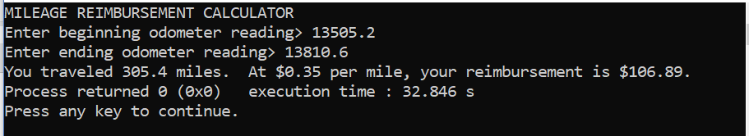

Submit the working .c file in the Assignment 1 Dropbox.